**Assignment Information and Goal**  
In this class assignment you will demonstrate a detailed knowledge of WordPress basic skills by creating a WordPress site and extending it with menus, images, themes, plugins, pages and posts and comments.   
The goal of this assignment is to demonstrate that you have learned how to create database tables and write PHP code to query their contents and display them on a WordPress page in a Custom WordPress Plugin.   
**Assignment questions are not as detailed as activity questions. The assignment is where you demonstrate understanding of the material.  
  
Read All Project Documents before Starting the Work**Please read this document completely before starting the project work.   
Please also read the template so that you understand what information, content, and screens you are required to capture and insert into the template file.

**Documents for This Assignment:**   
This is the assignment instructions document.   
It contains the information on the necessary tasks to be completed for the assignment.  
The other documents associated with this assignment are the assignment template, the website content, and the rubric.

**Assignment 06 Assets file:**   
The Website Content images are on the compressed Assets file.   
Please download and extract on your local computer.   
  
**Template File:**   
Please download, rename, complete and then submit the assignment template document to receive a grade for this assignment. Please provide partial screen captures where requested.  
The rubric provides detailed information on how the assignment is graded.  
**PLEASE DO NOT DELETE PARTS OR ALTER SECTION FORMATTING OF THIS TEMPLATE**

**Assignment Asset Folders and Website Content**   
There are asset folders that contain images and website page and post content.  
The asset folders contain images and content to use on the CMS website.   
Please use the content and image assets provided on the D2L CMS to complete the assignment.

**Asset Folders Information**There are no assets for this assignment. Please use your own images or past tutorial or assignment images and IPSUM content for Pages and Posts.

Please contact the instructors if you have questions about the assignment, content layout, or formatting.

**Part A - Student Information**

1. Download and save a copy of the Assignment 06 Template document
2. Rename the template document **[Your-Full-Name]-**Assignment06.docx
3. Go to the template and enter part A student information.

**Part B - Create WordPress CMS website on a Shared Web Host or Pantheon (PaaS) Platform**

1. If you are using a shared web host create an “In Directory” WordPress CMS website with the following attributes  
    **For Shared Web Host:**

**Protocol:** http:// **Domain:** Select your default domain **In Directory:** assignment06”

**Site Name:** “Custom Plugin Assignment”

**Site Description:** “IT320 Assignment 06”  
**Enable Multisite (WPMU):** Do not enable Multisite

**Choose Language: Set language to the default of English  
Select Plugins:**

**Limit Login Attempts – Uncheck this option**

**Do not use the Classic Editor on this assignment:**

**Classic Editor – Do not Enable (**DO NTO CHECK**) this option**

**Advanced Options:**

Database Name: Use your web hosts default database name

Database Prefix: Use your Web hosts default database prefix

-OR-  
**For Pantheon:**

If you are creating a Pantheon WordPress 5.0 site, create a site with the following attributes:  
**Site Name:** “Assignment 06 WP CMS”

1. Go to the template and record website creation settings in Part B.

Part C - Extend your WordPress site with Images, Menu, Pages, Categories, Posts and Comments

1. Add at least 3 images
2. Add a menu
3. Change the Theme to Camer
4. Add 2 Pages named Page Test 1 – Page Test 2 – each with 1 image
5. Add One Category named Test
6. Add 2 Posts named “Post Test 1” – “Post Test 2” with Category of Test – each with one image
7. Add 1 comment to each Page and Post
8. Go to the template and record website creation settings in Part C.

Part D – Create a new MySQL Table named employee

1. Create a MySQL DB Table in your WordPress DB named employee with the appropriate MySQL DB prefix and the following column settings:

ID – Type INT as an Auto-Increment + Primary Key  
Name – VARCHAR 50  
Age – INT   
EyeColor – VARCHAR 10  
Salary – DOUBLE

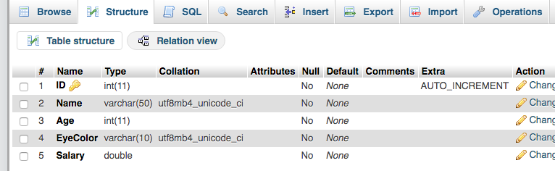

2. Go to the template and record website creation settings in Part D.

Part E – Add the following records to the employee table

1. Add following records to the employee table- exactly as listed  
   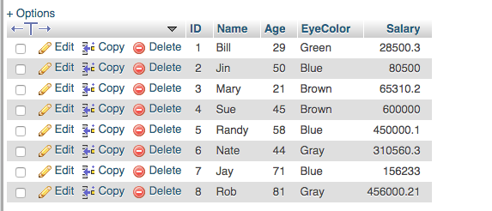
2. Export only the employee table to a .sql backup file
   1. Only export the employee table, not the entire database
3. Go to the template and record website creation settings in Part E.

Part F – Create and deploy an Employee Table Reader Custom WordPress Plugin

1. Install and activate the Classic Editor Plugin
2. Create a new WordPress custom plugin named employee-reader that queries the employee table and displays the iterated table contents in an HTML table on a Page named “Employee Reader Page” on your WordPress site
3. Create the custom plugin with the following requirement specifications:
   * Query employee table and display table contents on a WP page in an HTML table
   * For the Age data use a switch statement or conditional statements (IF-THEN-ELSE) to evaluate the integer Age value and output a string value as follows:
     1. For values <= 21 🡪 display “Young”
     2. For values >21 and < 45 🡪 display “Young Adult”
     3. For values >=45 and < 65 🡪 display “Adult”
     4. For values >65 🡪 display “Old Adult”
   * For Salary, use the money format function to format the Salary as US currency with a leading $ and a decimal point with two integers to the right of the decimal point.
     1. Recommended Money Format String: '%(#10n'
   * For the EyeColor data, display the EyeColor value as colored text. Make the formatted output value and color using HTML font color statement.
     1. Example: for $color variable: <font color=\"$color\">$color</font>

Example Output Page:  
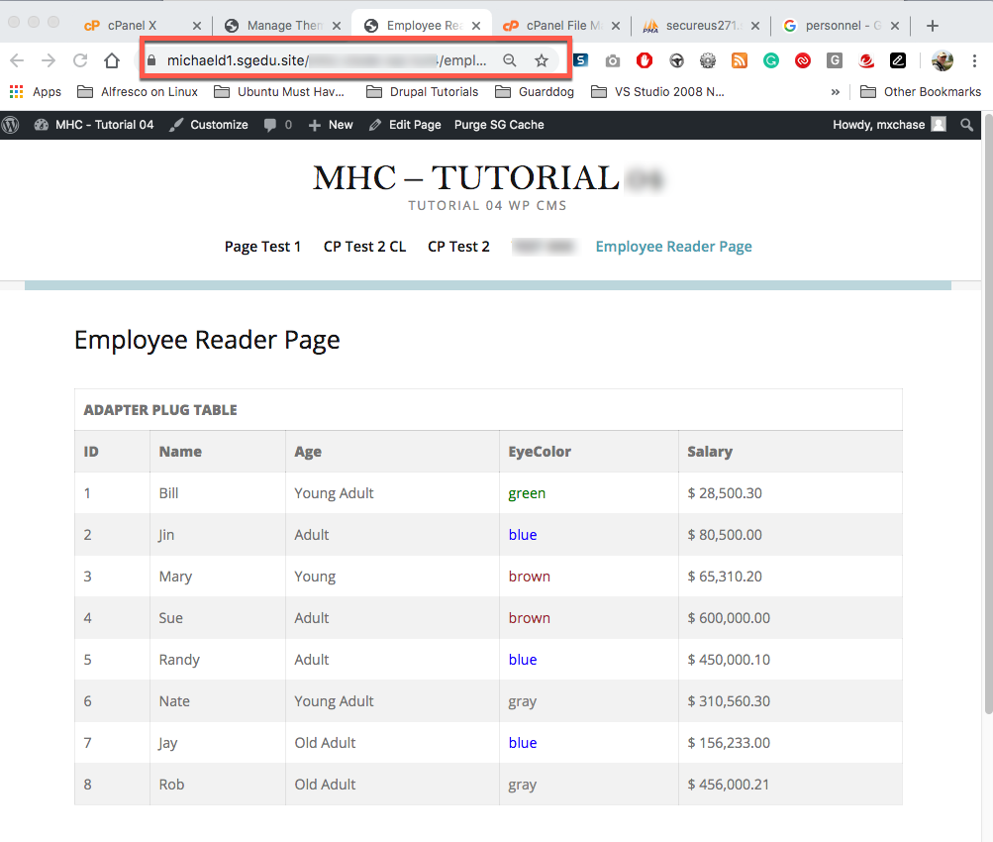

1. Deploy the employee reader custom plugin on your WordPress site
2. Add a Page to execute your Employee reader plugin
3. Go to the template and record the requested answers at Part F.

PART G - Assignment Wrap-up  
Go to the template and record the requested answers at Part G.

**Congratulations. You have completed this assignment.**

Submit your completed Assignment 06 Template to D2L.